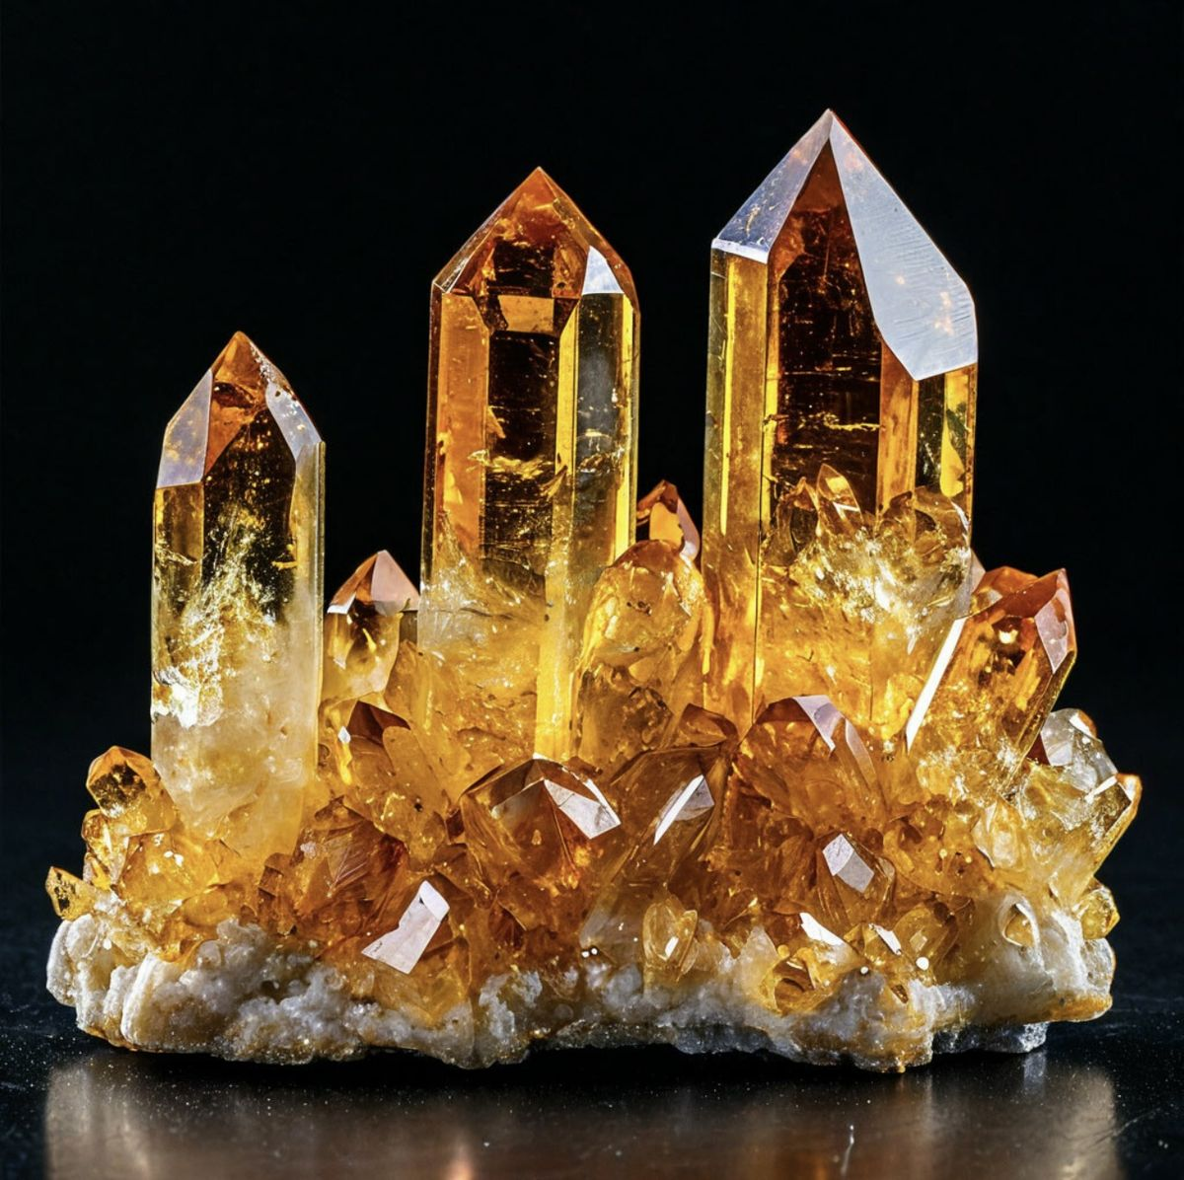
CITRINE AMBER
The blue diamond is one of nature’s most exquisite treasures, embodying grace, strength, and eternal beauty. Its vivid blue color captures the essence of the ocean’s depth and the boundless sky above, radiating calm and clarity. Each carefully cut facet reflects light like a prism, revealing layers of brilliance that seem almost otherworldly. This gem has long been a symbol of wisdom, truth, and devotion, admired by royalty and collectors alike. Its serene hue carries a tranquil energy that soothes the soul and clears the mind. Throughout history, blue diamonds have been associated with divine power and emotional balance, believed to bring inner peace and spiritual awakening. The gem’s flawless design showcases the perfection of natural artistry, crafted through immense time and pressure beneath the Earth’s surface. Its sparkle tells a story of resilience and transformation — a reminder that beauty is born through endurance. When held under light, the diamond glows with a celestial radiance, captivating hearts and inspiring dreams. More than a jewel, it is a symbol of loyalty, trust, and everlasting love. The blue diamond is cherished not only for its rarity but for its ability to touch the human spirit. It connects the elegance of nature with the brilliance of human craftsmanship. Every reflection reveals harmony between strength and serenity. Truly, the blue diamond stands as an icon of purity, power, and timeless luxury.

